COLD ASHBY VILLAGE (memorial) HALL
Main Street, Cold Ashby NN6 6EL
Charity number 1024816
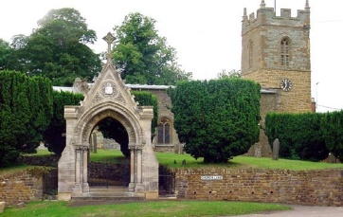
Annual General Meeting

Wednesday 16th June at 7 p.m. Sports Pavilion

Agenda

1.To elect/agree a chairman for the meeting (if the committee chairman is present, he will assume the chair).
2. Attendance: to record those present at the meeting.
3. Apologies
4. Minutes of the 2018-19 AGM
5. Matters arising from the minutes
6. Chairman's report
7. secretary/treasurer's report
8. Adoption of accounts for year 2019/2020.
9. To elect a committee in accordance with the trust deed to act until the next annual general meeting.
10. Four elected members plus one each to represent and elected by the Bowls Club, The Parish Council and the Parochial Church Council. Others as appropriate.
11. Programme of meetings until the November 21 AGM
12. To elect officers of the committee (chairman, secretary, treasurer)

G Jones, Secretary May 2021

NB: The AGM was postponed in November 2020 and this is the first opportunity to get together again. The Sports {Pavilion) has been chosen as a venue because it is a more Covid secure environment at the moment and because the annual village assembly is scheduled for the same evening at 7.30, or at whatever time the above AGM finishes if that is later than 7.30. The future of the Village Hall is an item on the assembly agenda.

Overleaf are the accounts for the full year 2019-2020 and the accounts for this year.

I hope to see you on the 16th and apologise that this meeting was called without the consultation we should have preferred.

